# Using SOAPUI Mock Service in weblogic

## 1 - Right click project and select “Generate SOAP Mock Service”

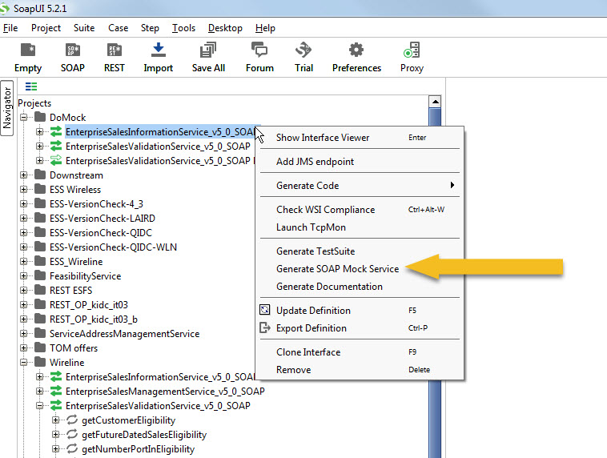

## 2 – Select Operations to mock

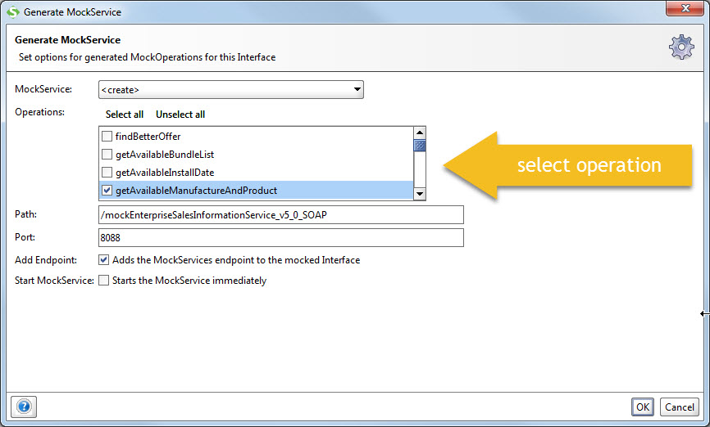

## 3 – Assign a name to the Mock Service

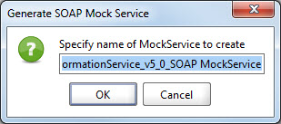

## 4 – Mock Service

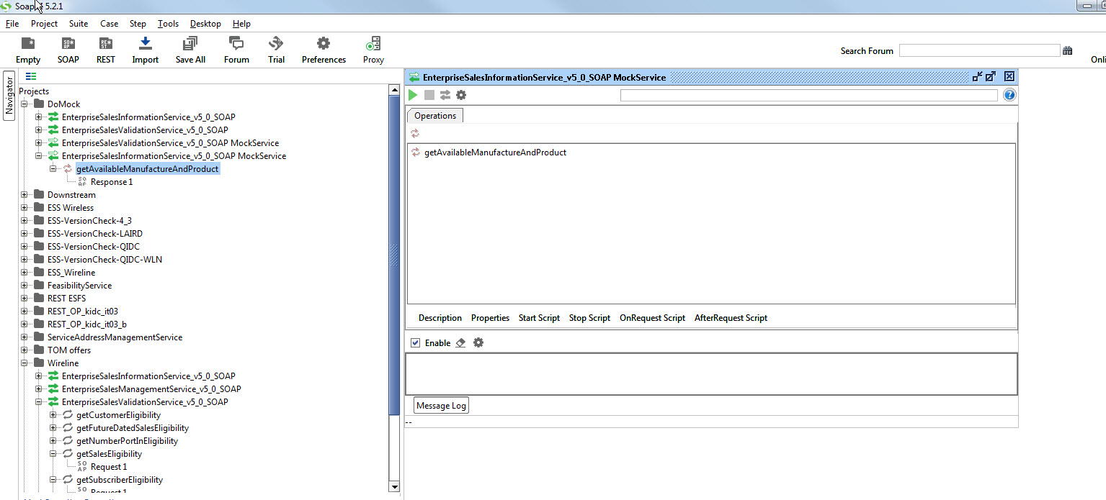

* Click the green arrow to start the mock service on the local machine

## 5 – create mock response

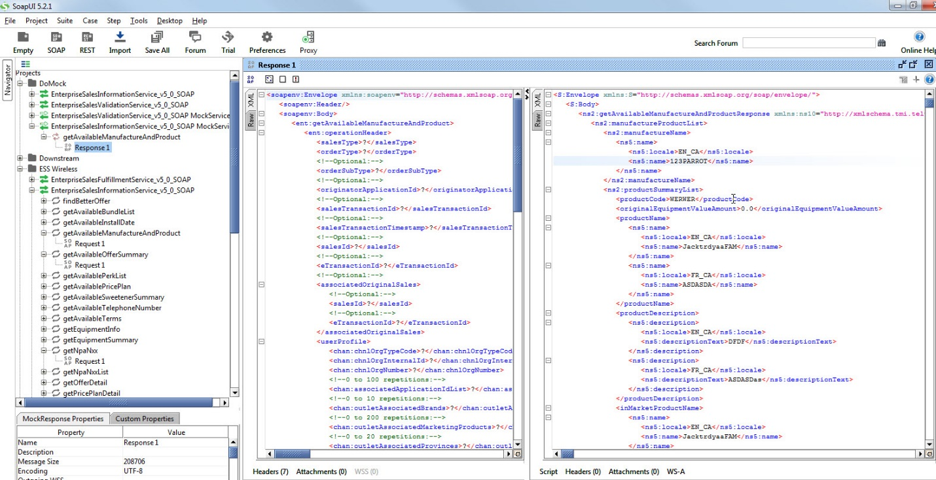

## 6 – test to ensure the mock is working

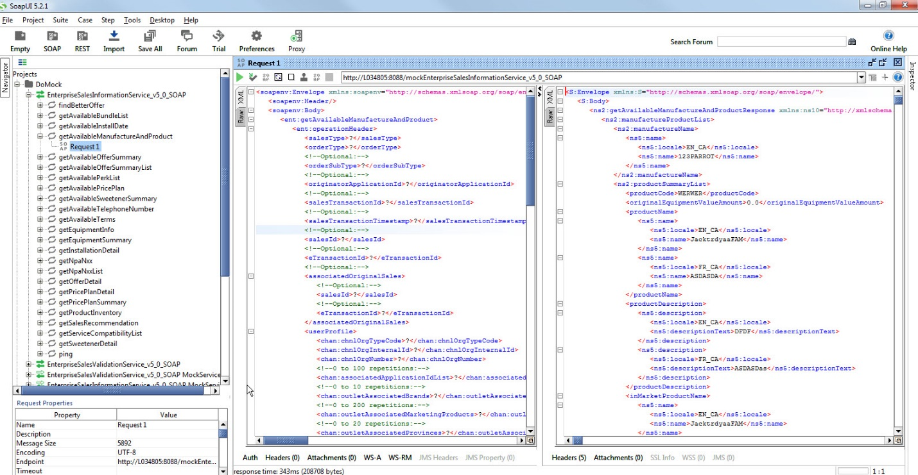

## 7 – right click project and select “deploy as WAR”

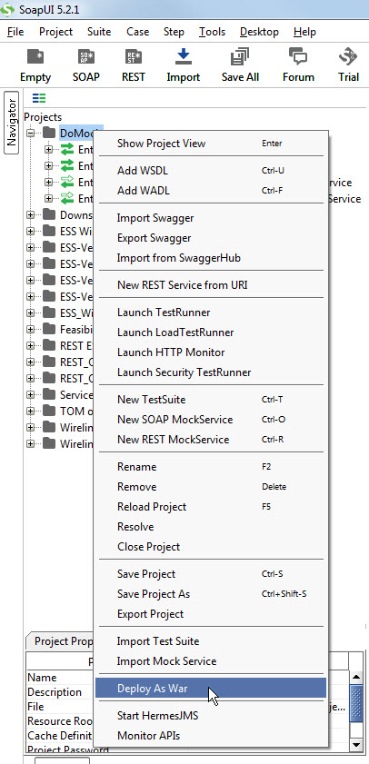<http://localhost:7001/console/console.portal?_nfpb=true&_pageLabel=AppApplicationInstallPage&AppApplicationInstallPortletFILECHOOSERPATH=C:\3_work\0_MOCK_SERVICE_EAR\wireline_weblogic-soapui-mock-ear-master>

## 8 – Configure WAR files setting

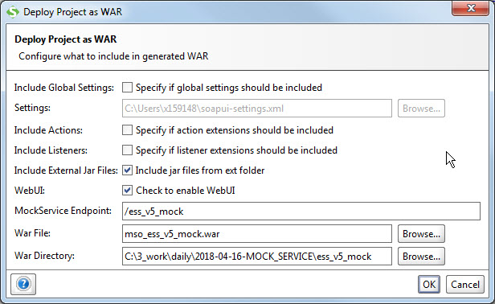

REST

+++++++++

MockerService Endpoint => /ewlnss_v5_rest_mock

War File => mso_ewlnss_v5_rest_mock.war

war directory => ..

MSO_REST_EWLNSS

SOAP

++++++++++++++++++++++

MockService Endpoint => /ewlnss_v5_soap_mock

War File => mso_ewlnss_v5_soap_mock.war

At this point, you can deploy the war file to tomcat and it will run fine. But in order to deploy to weblogic, it must be convert to an “ear” file.

From github, there is an existing project the just do that.

<https://github.com/eveoh/weblogic-soapui-mock-ear>

I have included the zip file here



# Build ear file for the mock service

1 - Expand the “weblogic-soapui-moc-ear-master.zip”

2 – modify file “gradle.properties” soapUiMockWar, the other can be leave alone if you decide to deploy the ear file yourself.

soapUiMockWar= *C:\\3_work\\daily\\2018-04-16-MOCK_SERVICE\\weblogic-soapui-mock-ear-master\\mso_ess_mock.war*

weblogicDeploymentName => mso_soap_ewlnss

weblogicDeploymentPath=MSO_SOAP_EWLNSS

3 – run “gradlew build”. For the first time, you may need to logoff from the telus network. It needs to reach out to intenet to pull the gradle images.

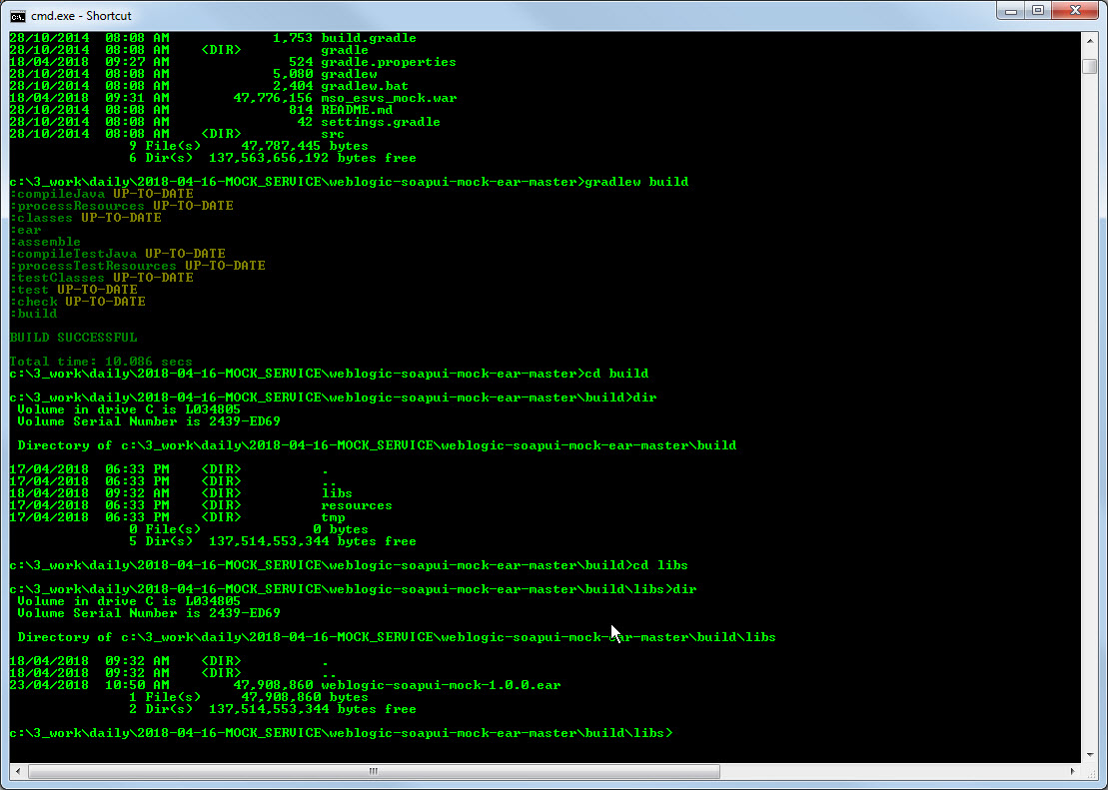

4 – the ear file will be in build\libs

5 – deploy the ear file into weblogic

6 – viewing the WSDL file => http://localhost:7001/MOS/ess_v5_mock?wsdl

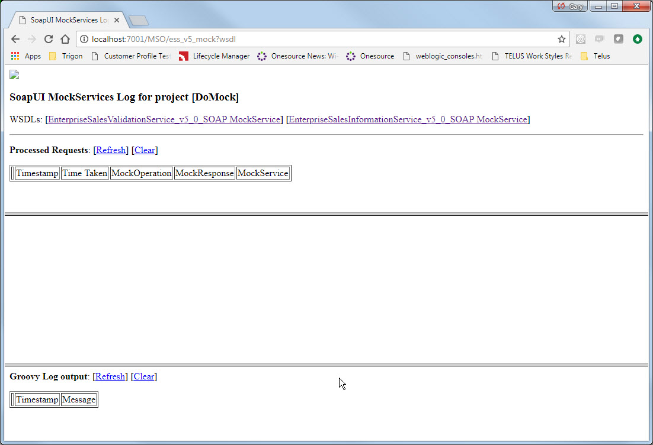

7 – WSDL for the service, click “EnterpriseSalesInformatioNService_v5_0_SOAP_MockService

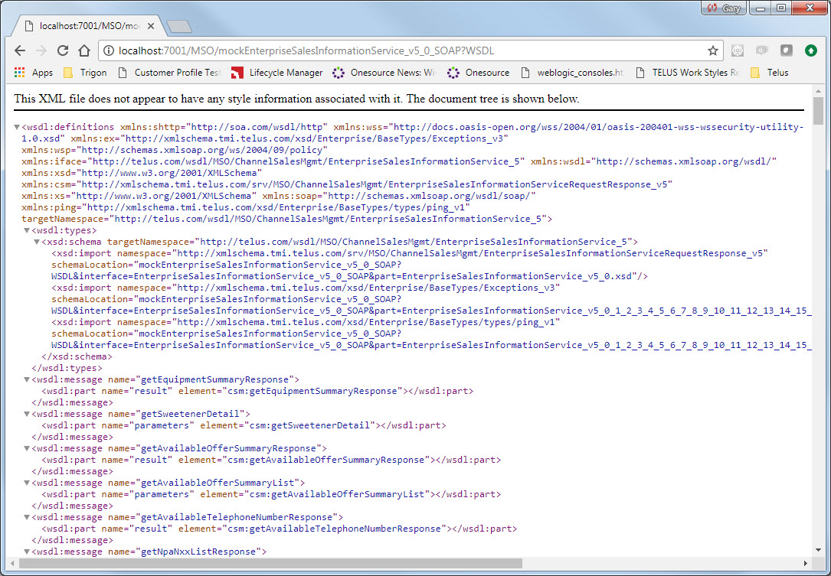

8 – testing from SOAPUI

Copy the above URL and remove “?WSDL” paste into SOAPUI as new URL 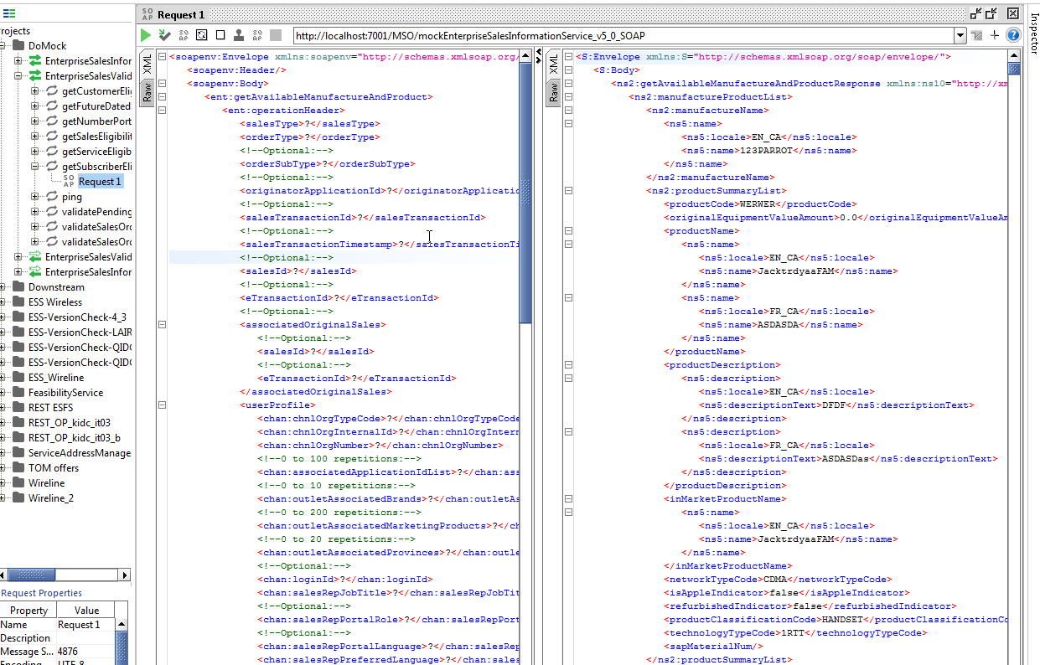

Resources

* <https://www.soapui.org/soap-mocking/working-with-mockservices.html>
* <https://www.soapui.org/soap-mocking/creating-dynamic-mockservices.html>
* <https://www.soapui.org/soap-mocking/mockoperations-and-responses.html>
* <http://www.softwaretestinghelp.com/soapui-mock-service-and-dynamic-response/>
* https://www.captechconsulting.com/blogs/enterprise-mock-services-with-soapui-part-1

# For WIRELINE MOCK Generation

## REST MOCK (C:\3_work\0_WIRELINE_REST_MOCK_EAR_BUILDER)

Sample gradle.properties

*soapUiMockWar=C:\\3_work\\0_WIRELINE_REST_MOCK_EAR_BUILDER\\wireline_REST_weblogic-soapui-mock-ear-master\\mso_ewlnss_v5_rest_mock.war*

*# Weblogic Admin URL and username and password. Used for automated deploys.*

*weblogicAdminUrl=t3://wlsserver:8002*

*weblogicUser=weblogic*

*weblogicPassword=weblogic123*

*# Name of the application.*

*weblogicDeploymentName=mso_rest_ewlnss*

*# Description of the application*

*weblogicDeploymentDescription=Recordingplanner SOAP service mock*

*# Path deployed to.*

*weblogicDeploymentPath=MSO_REST_EWLNSS*

## SOAP MOCK (C:\3_work\0_WIRELINE_SOAP_MOCK_EAR_BUILDER)

Sample gradle.properties

*# Location of the WAR file generated by SoapUI.*

*soapUiMockWar=C:\\3_work\\0_WIRELINE_SOAP_MOCK_EAR_BUILDER\\wireline_weblogic-soapui-mock-ear-master\\mso_ewlnss_v5_soap_mock.war*

*# Weblogic Admin URL and username and password. Used for automated deploys.*

*weblogicAdminUrl=t3://wlsserver:8002*

*weblogicUser=weblogic*

*weblogicPassword=weblogic123*

*# Name of the application.*

*weblogicDeploymentName=mso_soap_ewlnss*

*# Description of the application*

*weblogicDeploymentDescription=Recordingplanner SOAP service mock*

*# Path deployed to.*

*weblogicDeploymentPath=MSO_SOAP_EWLNSS*